[Finance and economics](https://www.economist.com/finance-and-economics/) | Buttonwood

Forget the S&P 500. Pay attention to the S&P 493 忘掉标普500吧，看看标普493

## The alternative benchmark offers a better view of America’s stockmarket

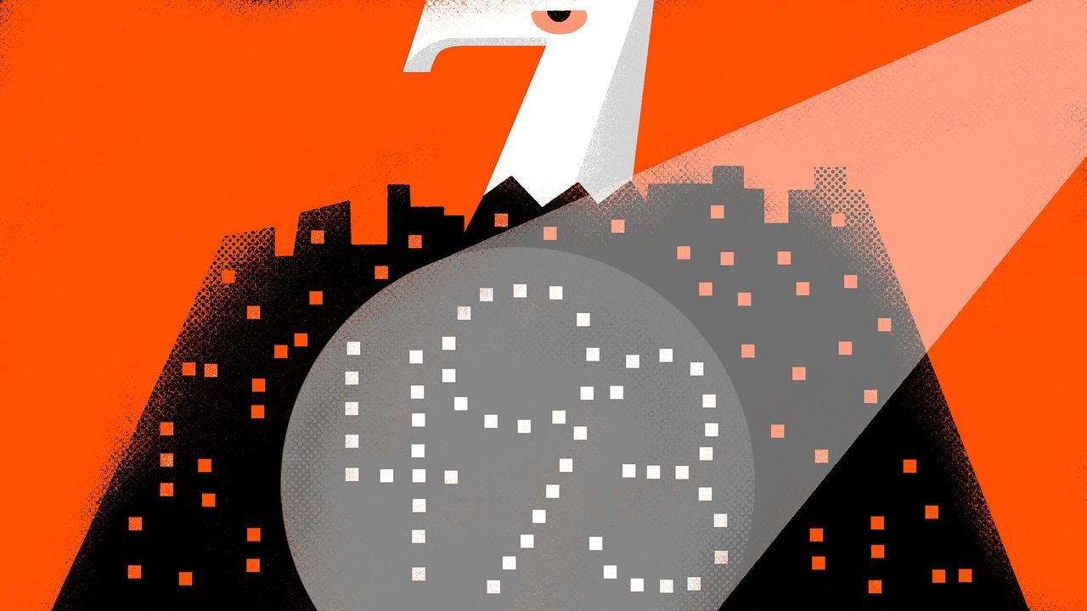

Think of America’s stockmarket. What is the first firm that springs to mind? Perhaps it is one that made you money, or maybe one whose shares you are considering buying. If not, chances are you are thinking of one of the big hitters—and they don’t come much bigger than the “magnificent seven”.

请想象一下美国的股票市场。你首先想到的是哪家公司？也许是一家让你赚钱的公司，或者是一家你正在考虑购买其股票的公司。如果不是，那么很有可能你在想的是其中一家明星公司，而且没有什么公司比"七巨头"更大的了。

Alphabet, Amazon, Apple, Meta, Microsoft, Nvidia and Tesla are Wall Street’s superstars, and deservedly so. Each was established in the past 50 years, and five of them in the past 30. Each has seen its market value exceed $1trn (although those of Meta and Tesla have since fallen, to $800bn and $700bn respectively). Thanks to this dynamism, it is little wonder that America’s stockmarket has raced ahead of others. Those in Europe have never produced a $1trn company and—in the past three decades—have failed to spawn one worth even a tenth as much. Hardly surprising that the average annual return on America’s benchmark s&p 500 index in the past decade has been one-and-a-half times that on Europe’s Stoxx 600.

Alphabet、亚马逊、苹果、Meta、微软、英伟达和特斯拉都是华尔街的超级明星，而且是实至名归的。每家公司都在过去50年内成立，其中五家在过去30年内成立。每家公司的市值都超过了1万亿美元（尽管Meta和特斯拉的市值后来分别降至8000亿美元和7000亿美元）。得益于这种活力，美国股票市场遥遥领先于其他市场也就不足为奇了。在过去的三十年里，欧洲从未诞生过市值1万亿美元的公司，甚至连这些科技巨头公司市值十分之一的公司都没有出现。所以难怪在过去十年里，美国标准普尔500指数的年平均回报率是欧洲斯托克600指数的1.5倍。

There is just one problem with this story. It is the hand-waving with which your 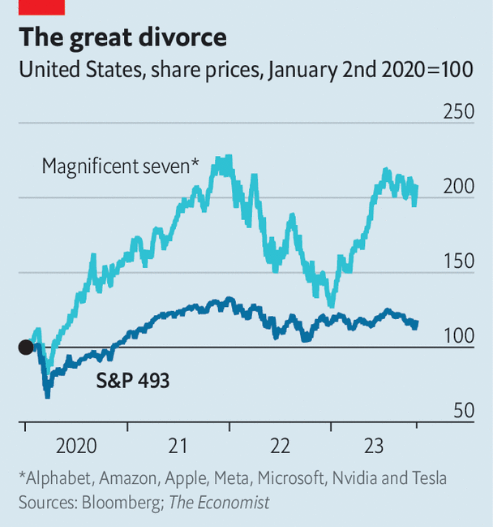columnist cast the magnificent seven as being somehow emblematic of America’s entire stockmarket. This conflation is made easily and often. It is partly justified by the huge chunk of the s&p 500 that the magnificent seven now comprise: measured by market value, they account for 29% of the index, and hence of its performance. Yet they are still just seven firms out of 500. And the remaining 98.6% of companies, it turns out, are not well characterised by seven tech prodigies that have moved fast, broken things and conquered the world in a matter of decades. Here, then, is your guide to the s&p 493.

这个故事很美好，仅仅只有一个问题。就是专栏作家往往“打手一挥”就把七巨头与美国整个股票市场画上等号。这种混淆很容易而且经常发生。部分原因是七巨头如今在标准普尔500指数中所占份额巨大：其市值占所有成分股总市值的29%，因此能很大程度上左右指数涨跌。然而，它们仅仅是500家公司中的七家。剩下的98.6%的公司，事实证明，这七个在短短十年内快速发展、颠覆市场、征服世界的科技奇才并不能代表剩下98.6%的公司。因此，我们将为您介绍标准普尔493的指数。

Most obviously, having discarded the tech behemoths, our new index now looks substantially older. Consider its biggest companies. At the top of the list is Berkshire Hathaway, an investment firm led by two nonagenarians, and Eli Lilly, a pharmaceuticals-maker established in the 19th century by a veteran of America’s civil war. Further down is JPMorgan Chase, a bank that made its name before the founding of the Federal Reserve. That is not to suggest that these firms do not innovate. All of them, by definition, have remained highly successful, even if none has crossed the $1trn threshold. Whippersnappers, though, they are not.

首先，显而易见的是，踢除了科技巨头后，我们的新指数看起来更加古老。让我们来看看其中最大的几家公司。位列榜首的是伯克希尔·哈撒韦，一家由两位九旬老人领导的投资公司，以及伊莉莉制药公司，一家由一位美国内战老兵于19世纪创立的制药公司。再往下是摩根大通银行，这家银行甚至在美联储成立之前就已名声在外。所有这些公司都是的的确确的成功企业，即使没有一家公司的市值突破了1万亿美元的门槛。但它们并不是初生牛犊。

As a result of this maturity, the s&p 493 is less susceptible to the market’s changing mood (see chart). This is a double-edged sword. On the plus side, it offered protection during the crash of 2022. The more established business models of s&p 493 companies started the year with less hype than those of the magnificent seven, leaving them less vulnerable when the hype duly evaporated. Meanwhile, a smaller proportion of their value came from the promise of distant future earnings—the present value of which fell dramatically as interest-rate expectations soared. The net effect was that, while the magnificent seven together lost 41% of their value, the s&p 493 lost just 12%.

也正是因为这些公司的成熟性，标准普尔493指数对市场的情绪变化不太敏感（见图表）。这是一把双刃剑。好的方面是，使他们在2022年的崩盘中得到了保护。标准普尔493公司更成熟的商业模式受到的炒作比七巨头在年初时炒作更少，当这种炒作逐渐消失时，它们相对没那么容易受到影响。与此同时，它们市值中只有一小部分是来源于对远期收益的承诺，而随着利率预期飙升，这些承诺的现值会大幅下降。结果是，尽管七巨头的市值蒸发了41%，标准普尔493的市值只蒸发了12%。

This year, however, the tables have turned. On the face of it, the old-timers ought to have done well, since the American economy has remained remarkably buoyant. This, combined with enthusiasm concerning the potential of artificial intelligence to juice their profits, led to a stellar recovery for the magnificent seven. In the first ten months of the year their share prices rose by 52%, nearly erasing the losses of 2022. By contrast, the value of the s&p 493 fell by 2%.

然而，今年情况发生了逆转。表面上看，老牌公司理应表现不错，因为美国经济一直保持着惊人的活力。加上人工智能带来了提升利润的乐观前景，使得七巨头的股票有了惊人的复苏。今年前十个月，它们的股价上涨了52%，几乎抹去了2022年的损失。相比之下，标准普尔493的价值下跌了2%。

What to make of this bifurcation? One conclusion is that America’s tech giants have become overvalued and must eventually face a crash. Another is that, just as share prices have diverged, so too will the companies’ sales and profits, meaning that the magnificent seven really are about to leave the dinosaurs in the dust. Investors seem to choose between these hypotheses largely according to their own temperament, since traditional valuation measures such as the price-to-earnings ratio, which for the magnificent seven is roughly double that for the s&p 493, lend support to both camps.

对于这种二分现象，我们能得出什么结论呢？一种结论是，美国的科技巨头的股价已经被过度估值，必将面临崩盘。另一种结论是，就像股价分化一样，后面这两类公司的销售和利润也将分道扬镳，这意味着七巨头将真的要让前人们望尘莫及。投资者似乎主要是根据他们的喜好来进行取舍，因为传统的估值指标来看，比如七巨头的市盈率大致是标准普尔493的两倍，两种观点都有几分道理。

A third conclusion, now aired increasingly often, is that the s&p 500’s domination by seven stocks which are so different from the rest means it is no longer a good benchmark. That is not quite right. Many people invest in funds tracking the index precisely so they can capture the gains of the winners without having to care about its composition. Still, if you want to know what America’s stockmarket really looks like, avoid the headline index. Look at the s&p 493.

现在越来越多地被提及到的第三个结论，是标准普尔500指数被七只与其他股票差异很大的股票主导，意味着它不再是一个好的基准。这并不完全正确。许多人投资于追踪该指数的基金，正是为了能够无脑的跟随投资获胜者获取收益而不必关心其组成。然而，如果你想知道美国股票市场的真实情况，还是得撇下标普500，看看标准普尔493。